Nursery Peek at the Week
Weekly News
We were all really proud of our Nursery children for performing in our Nativity shows this week. They sang beautifully and remembered all of the Makaton actions. This week we have continued to enjoy the Christmas festivities and we have been thinking about different ways that people celebrate Christmas.
The children are becoming increasingly confident when continuing repeating patterns and some of the children are even able to create their own pattern using two colours. The children have been very busy making Christmas cards for their families and we made some to deliver to school staff to thank them for everything that they do to help us. The children have also become increasingly confident at giving meanings to their marks when drawing and they have created some fantastic letters to Santa.
We will have some new children joining us in January and I am sure that you show them a lovely Dorchester welcome!
Thank you for all of your support this term, I would like to take this opportunity to wish you all a Merry Christmas and a Happy New Year!
aglover13@suttonmail.org -Annabel Glover-Nursery Class Teacher, EYFS lead and Phonics Lead
REMEMBER No question or concern is too small, I would rather you email me than worry about something!

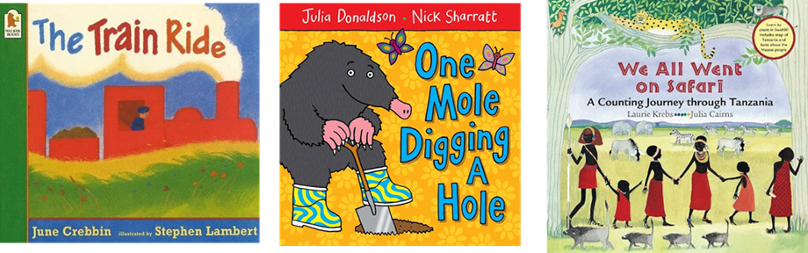
Our 3 a day books for Next half term are:
3-a-day Stories: The children have learnt our last 3 a day stories really well. These are our new 3 a day stories for this half term:

Dip and Do: Home Learning:
- Can you do something to help your family over the Christmas holidays?
- Can you continue or create a repeating pattern e.g. red, blue, red, blue, red, blue?
- Do you celebrate Christmas? If so, what do you do? Have you decorated your house for Christmas? We would love some photos of Christmas celebrations to put in our floor book!
- If you do not celebrate Christmas, do you celebrate any other festivals? We would love to have photos of any celebrations for our class floor book including Christmas, birthdays, Diwali, Eid or anything else.

What have we been learning in Nursery this week?
Look at our fantastic letters to Santa
(You may have to zoom in a bit to see the meaning that each child applied to their marks).
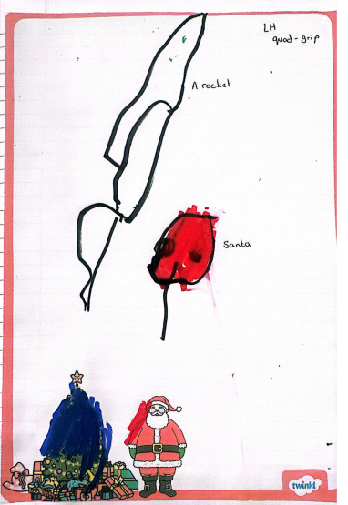
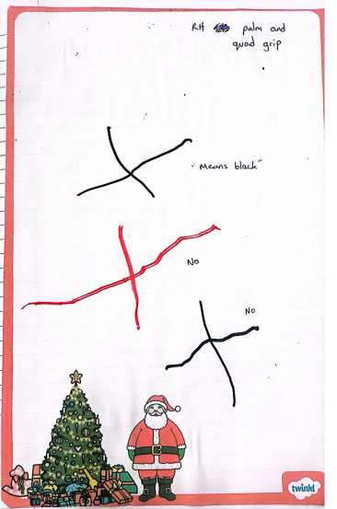
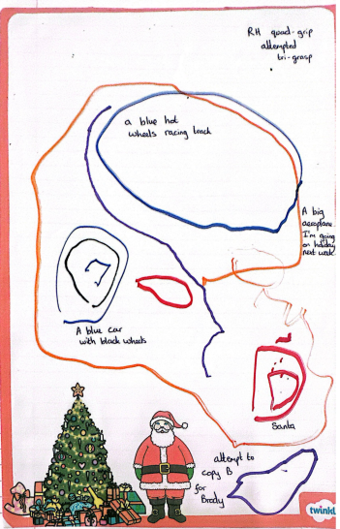
Dushel
Nicolas
Brody
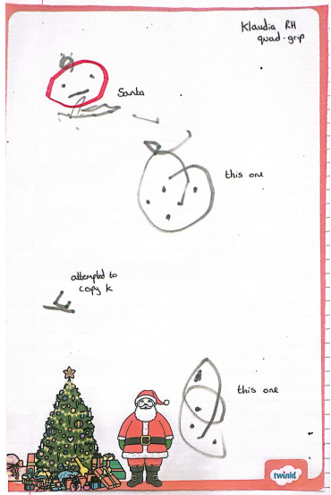
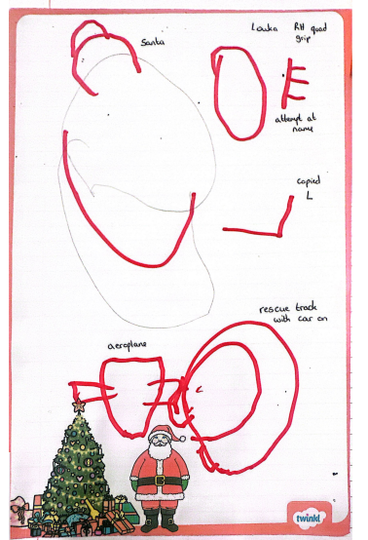
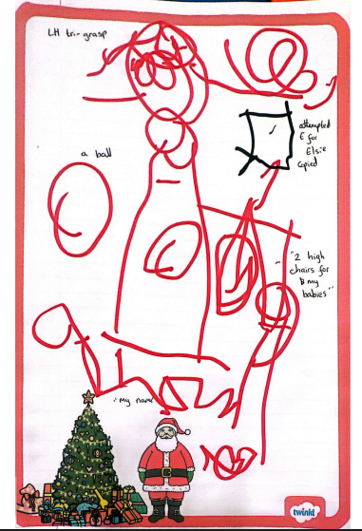
Klaudia
Louka
Elsie

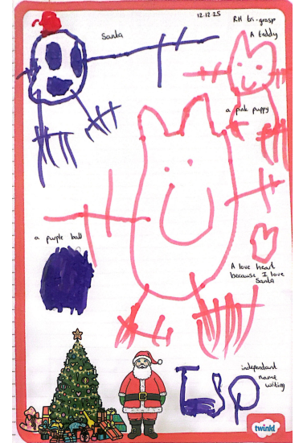
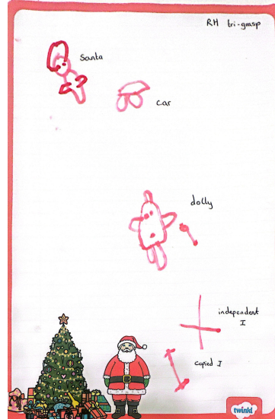
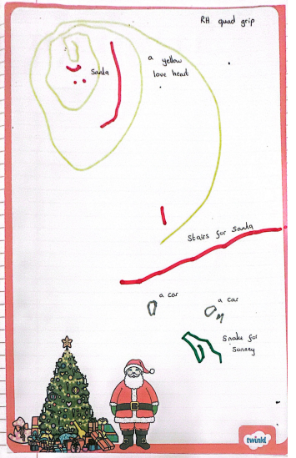

Isla
Ivy
Sonney
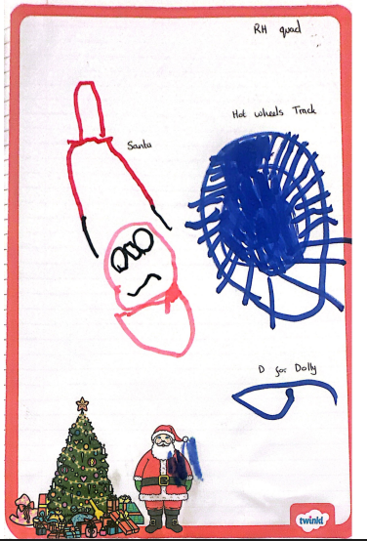
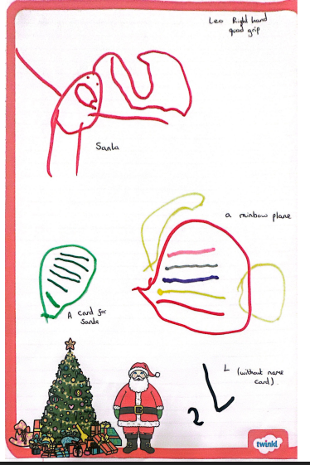
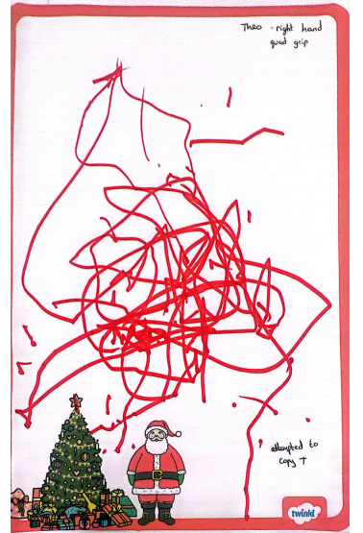
Dolly
Leo
Theo

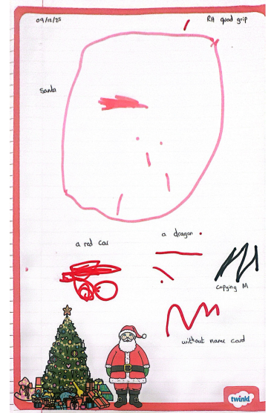
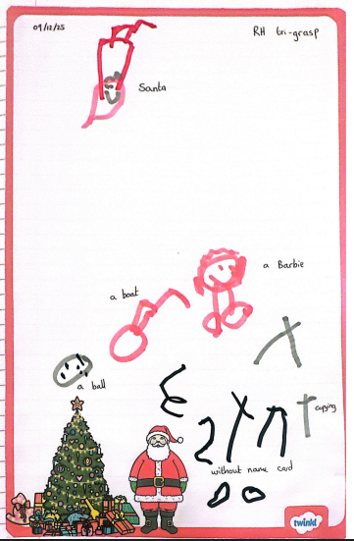

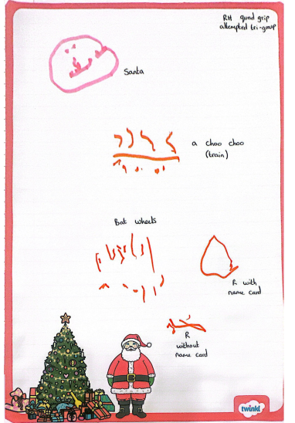

Mubahil
Talia
Raul

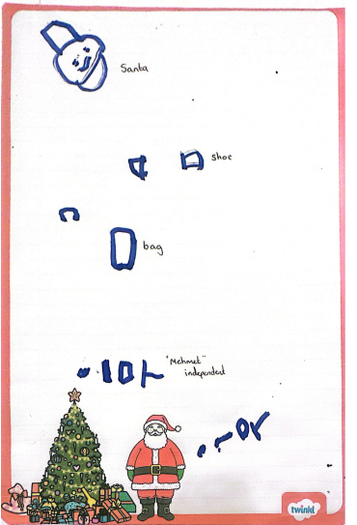
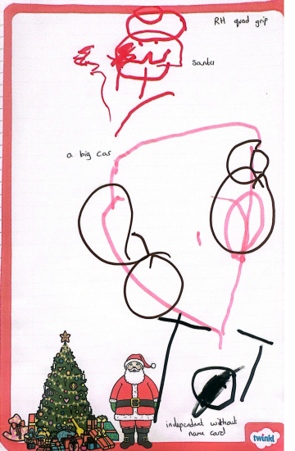
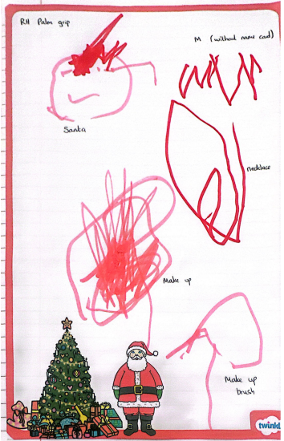

Mehmet
Tommy
Mila
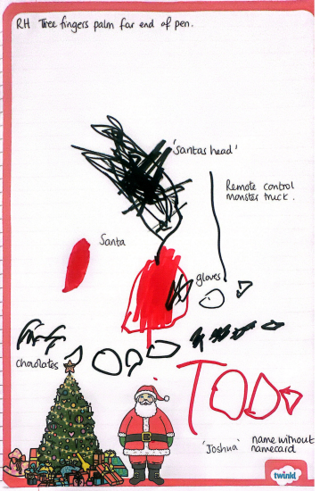
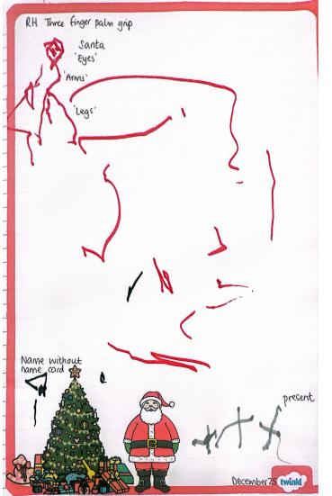
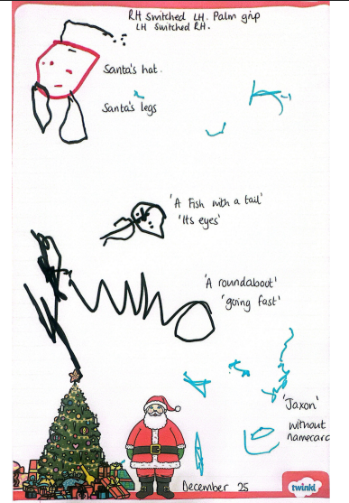

Joshua
Mabroor
Jaxon M
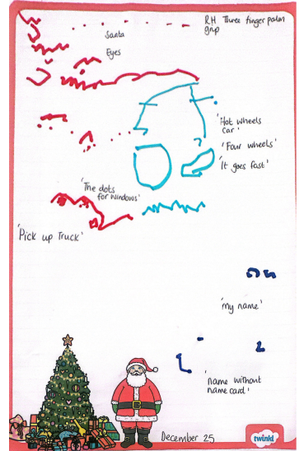
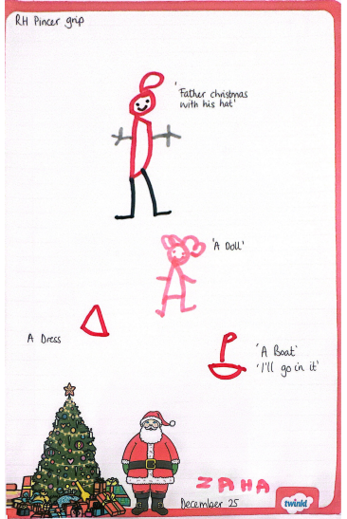
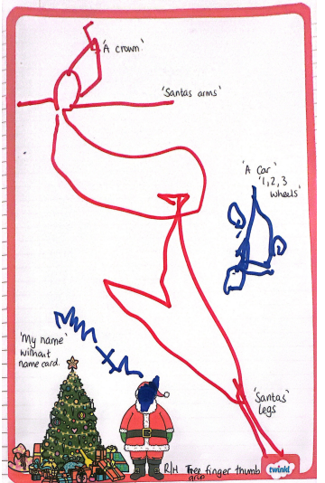

Heyaansh
Zaha
Jesse
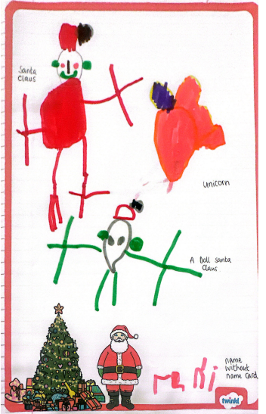
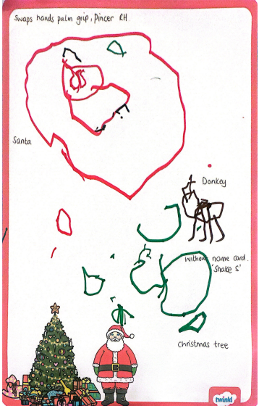
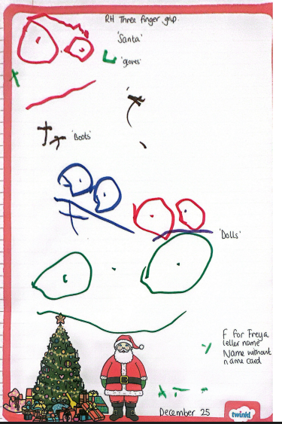

Freya
Sofia
Rani
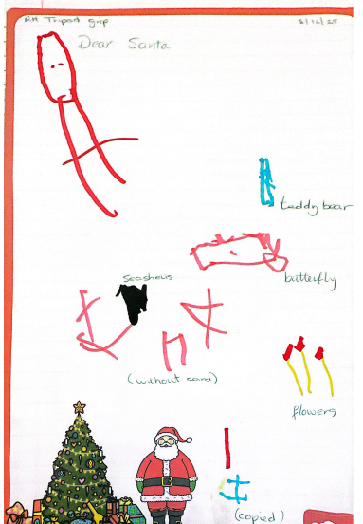
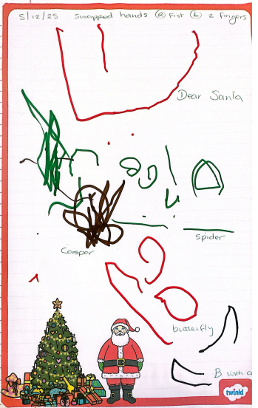
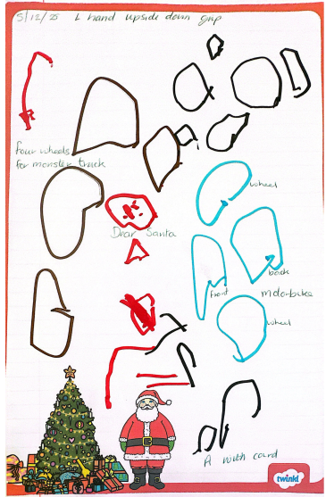

Isabella
Ben
Ayden

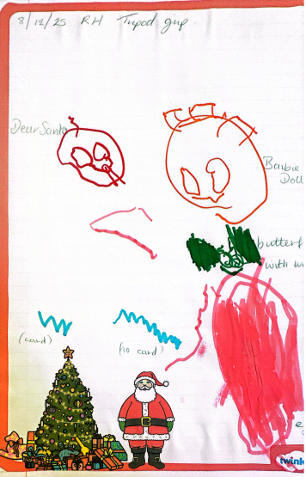
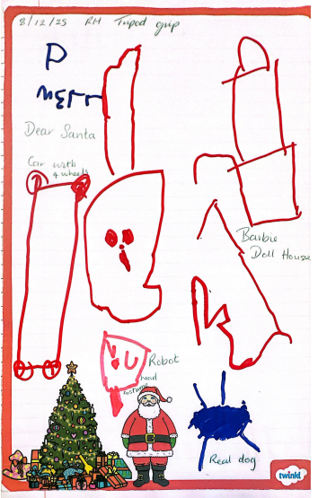
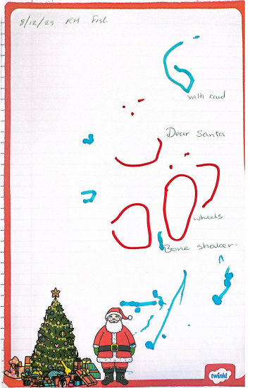

Mia
Margot
George

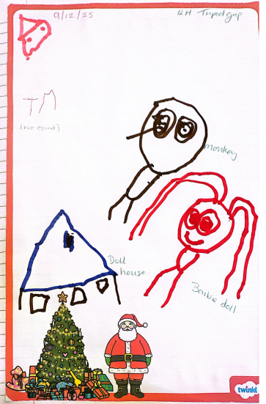
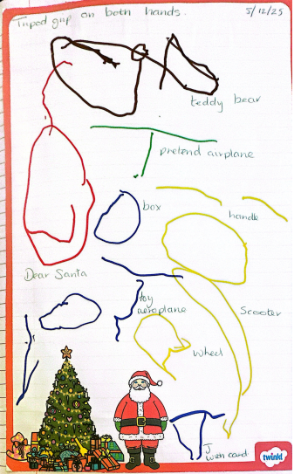
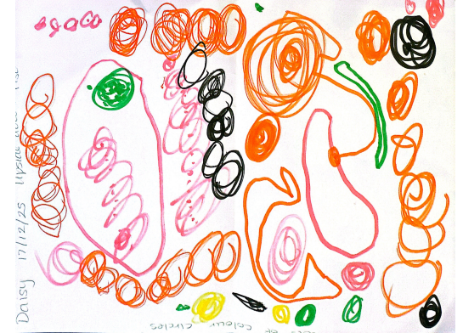

Daisy
Jaxon J
Teyana

Important Dates
First Day of Spring 1 - Tuesday 6th January 2026

Nursery Parents/carers WhatsApp
If you have not yet joined the Nursery Parents/carers WhatsApp and would like to please use the QR code below. This is a group managed by our Nursery parent Reps. It is really useful for reminders of different events and information about the school.


