Nursery Peek at the Week
Weekly News
This week, we have continued our exciting learning journey about pirates! The children were fascinated by some of the interesting facts we explored — many were surprised to discover that pirates still exist today and that women can be pirates too!
Alongside our pirate adventures, we have also been diving into the ocean to learn about sea creatures. The children enjoyed discovering the amazing animals that live under the sea and loved exploring, using different materials to create their very own sea creatures.
Next week we are going to be reading ‘All About Families’ by Felicity Brooks and Mar Ferrero. We will also be having meaningful conversations about who is in our family. Please bring in photographs including different members of your family. Please have a conversation with your child about who they are, and how they are related to them, e.g. Grandma is Mummy’s Mum.

If you have, any questions please do not hesitate to email me, or Munaza, using the email addresses below:
aglover13@suttonmail.org -Annabel Glover-Nursery Class Teacher, EYFS lead and Phonics Lead
mahmad68@suttonmail.org – Munaza Ahmad- Nursery Class Teacher


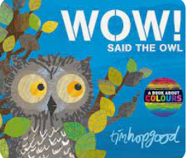

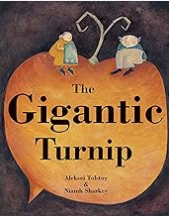
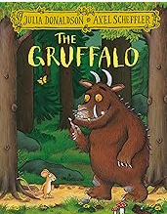
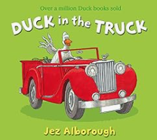
3-a-day Stories for Amber, Casper and Millie group children: The children have learnt our last 3 a day stories really well. These are our new 3 a day stories for this half term:

3-a-day Stories for Ollie group children: These are stories that the children hear every day. These stories have been carefully chosen to help the children to develop a love of reading and to help them to develop early reading skills. These stories have key elements that support the children to retell them for example many of them use rhyme or repeated phrases.



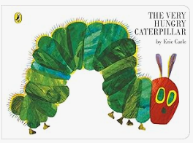
Dip and Do
These are some ideas of things that you may like to do to support your child’s learning at home.
- Can you talk about who is in your family?
- Can you make a family tree?
- Can you continue practising writing your name?
- Can you find different ways to make numbers up to five?
- Can you use materials and tools at home to create your own pirate ship or sea creature?

3-a-day Stories for Ziggy group children (these are our new children): These are stories that the children hear every day. These stories have been carefully chosen to help the children to develop a love of reading and to help them to develop early reading skills. These stories have key elements that support the children to retell them for example many of them use rhyme or repeated phrases.

What have we been learning Nursery?
What kind of creatures live in the sea?
What do you know about pirates?
What do pirates like wearing?

Please show your child these pictures and encourage them to talk about them.
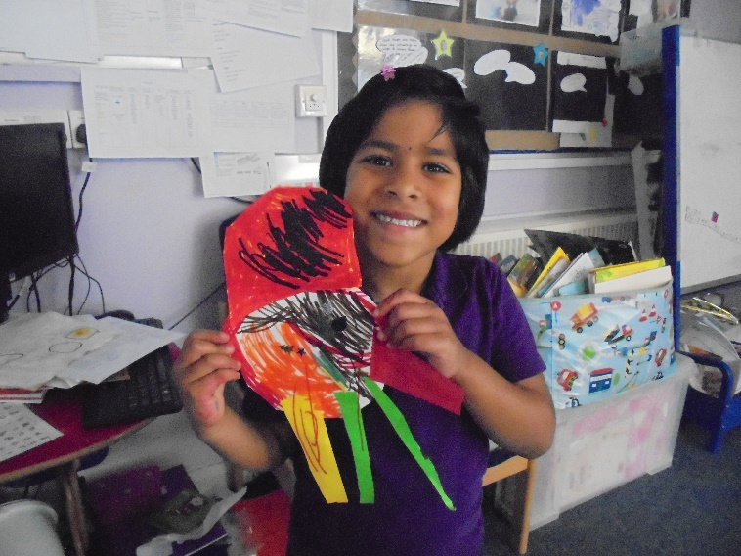

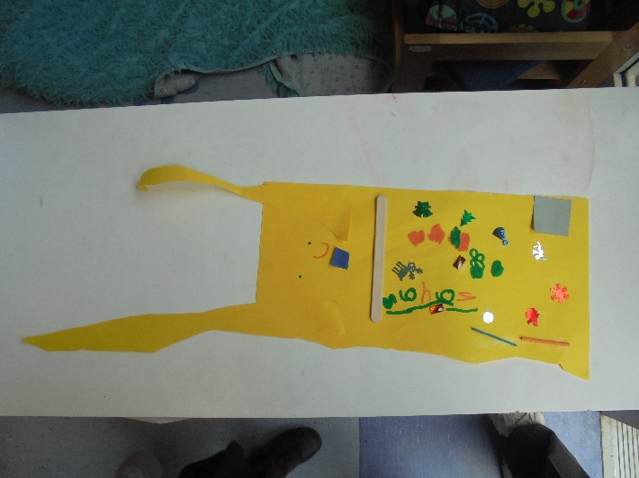

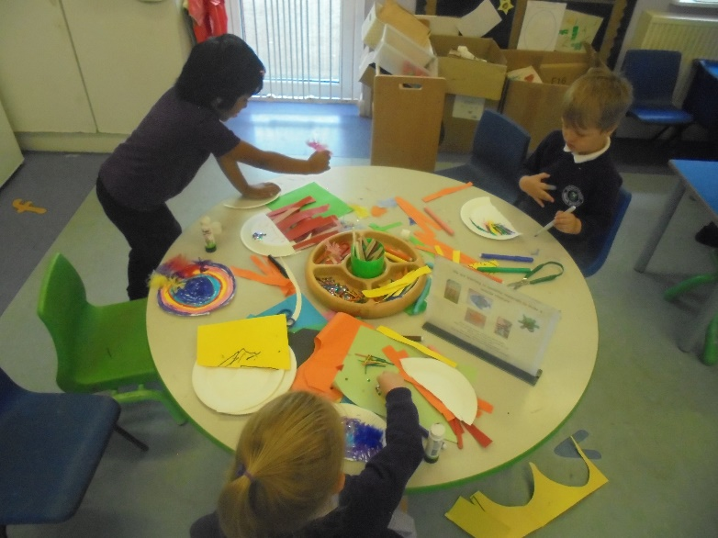
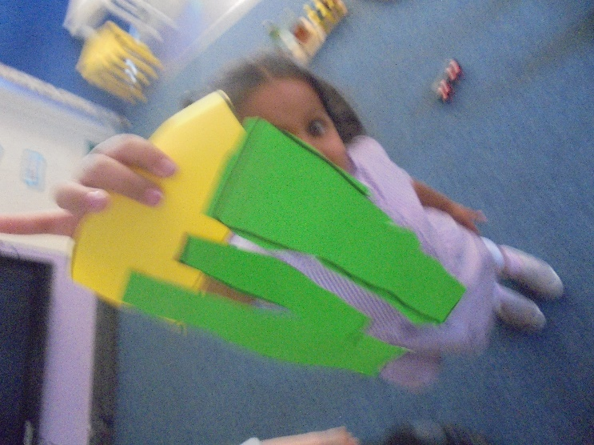
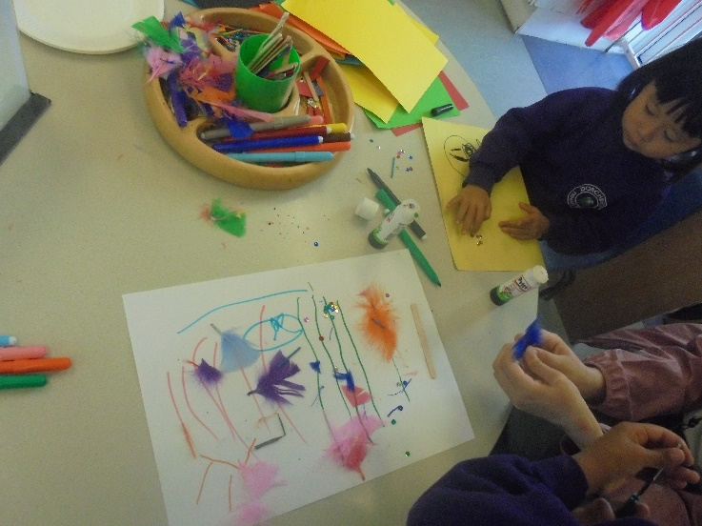
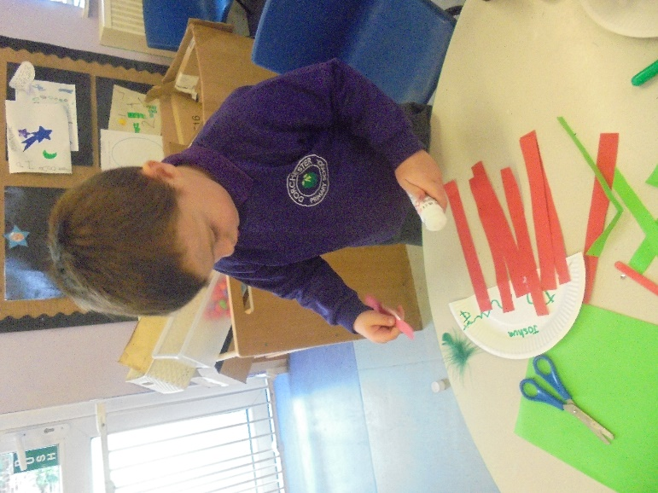

We have been using different materials and tools to create our very own sea creature!
What kind of creatures live under the sea?
What did you use to make your sea creature?

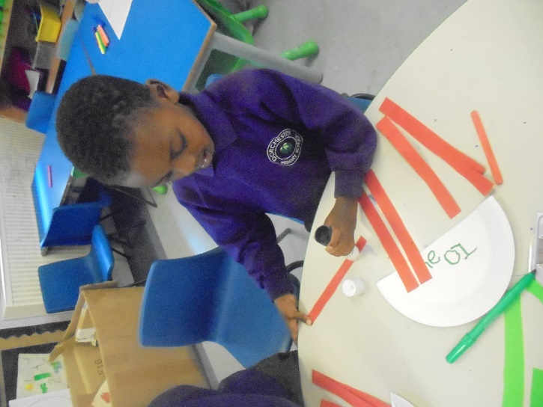

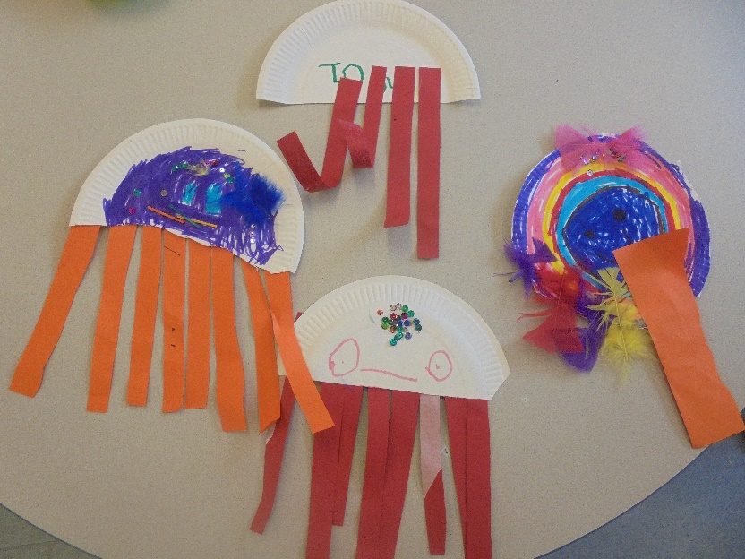

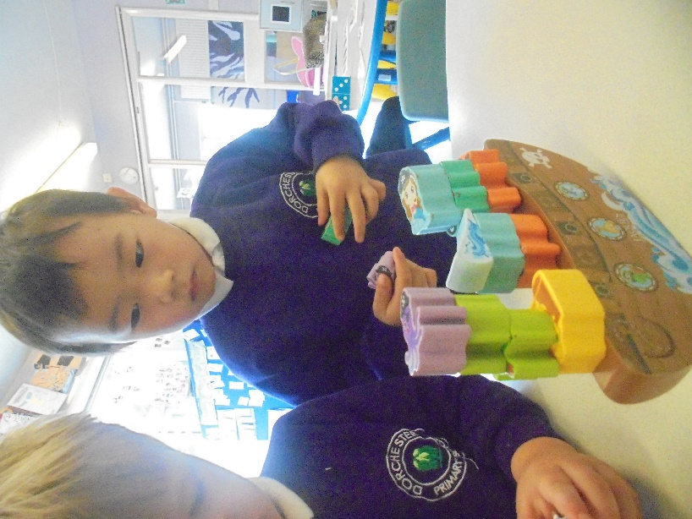
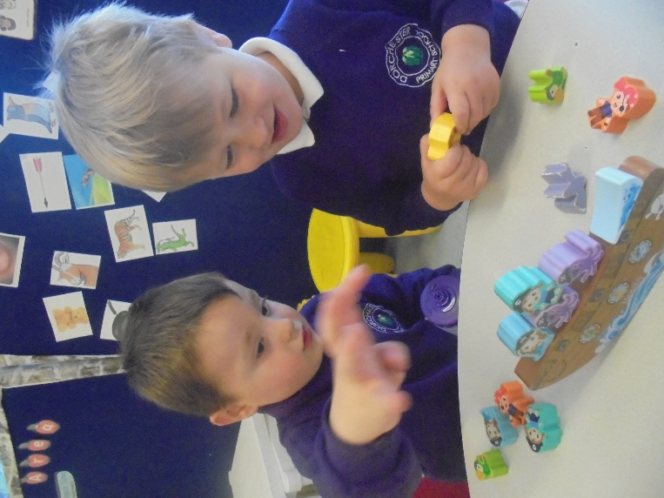

Using their fingers with control, the children had to balance all the objects on the wobbly ship.
Was it tricky to balance the objects? Why?
Is there another way?

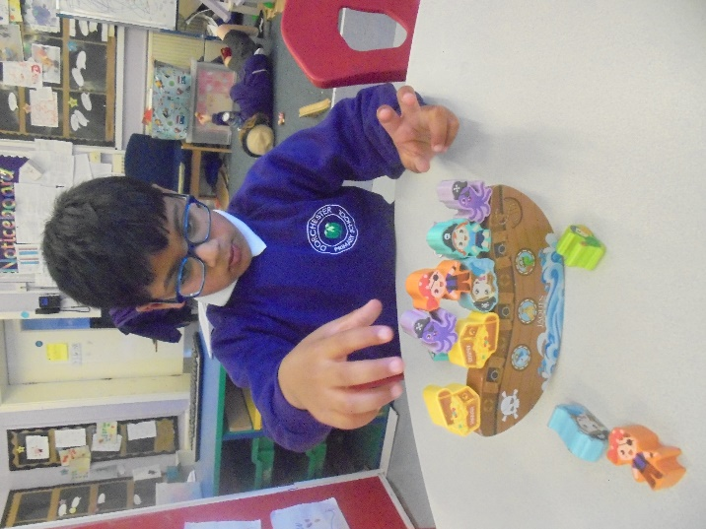

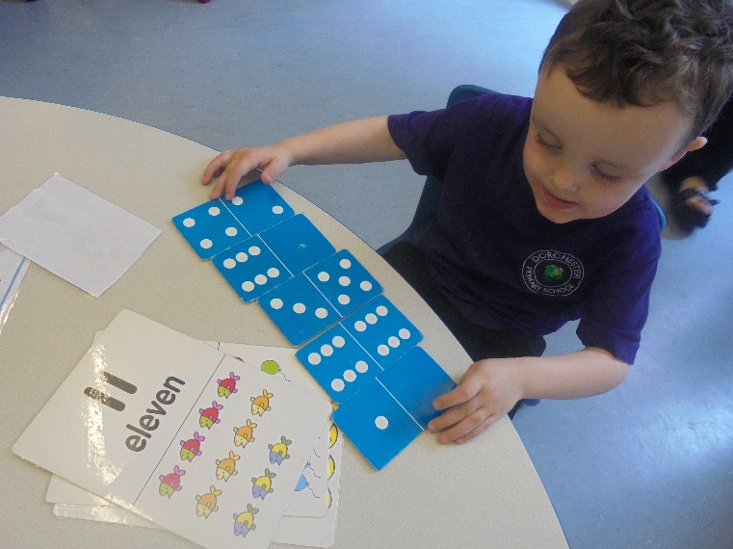
In Maths, we have been looking at different ways we can make numbers to five using dominoes.
What can you see?
How can you make that number?
Is there another way?

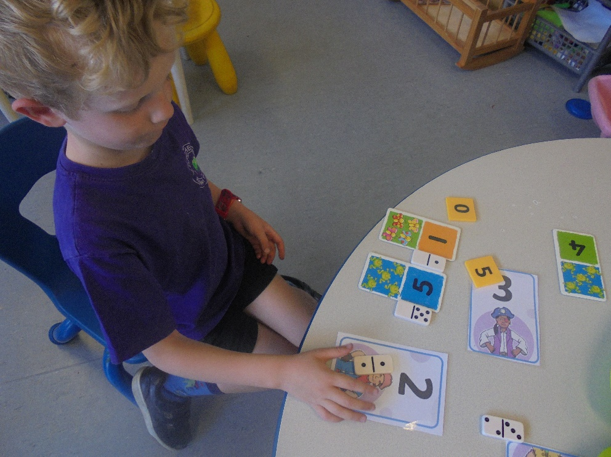

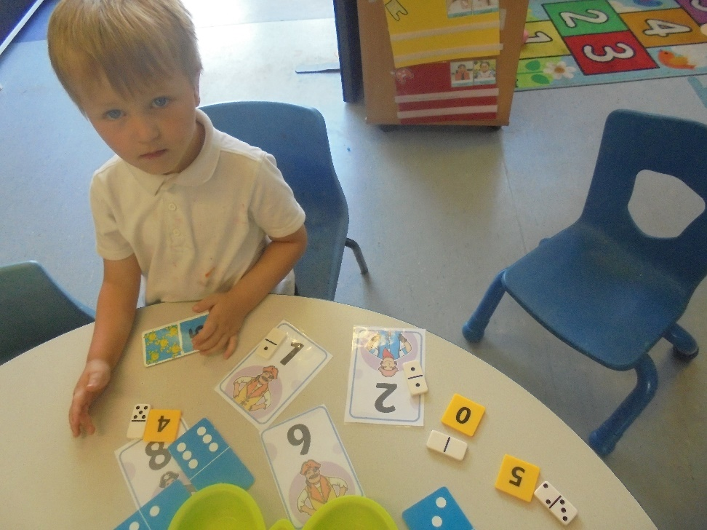

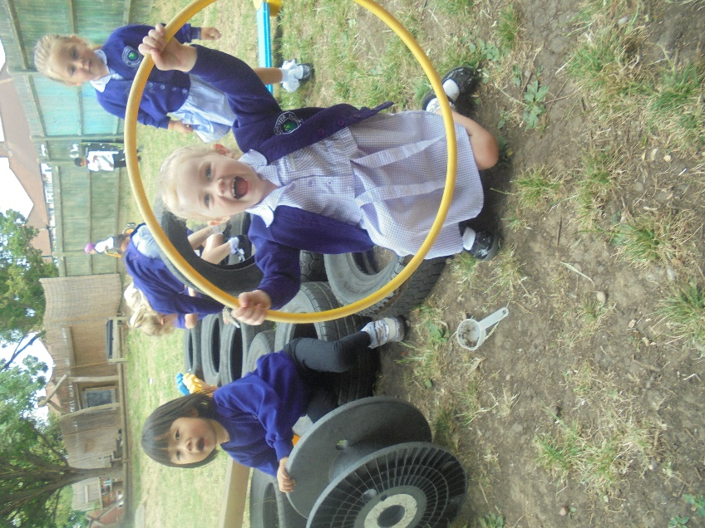
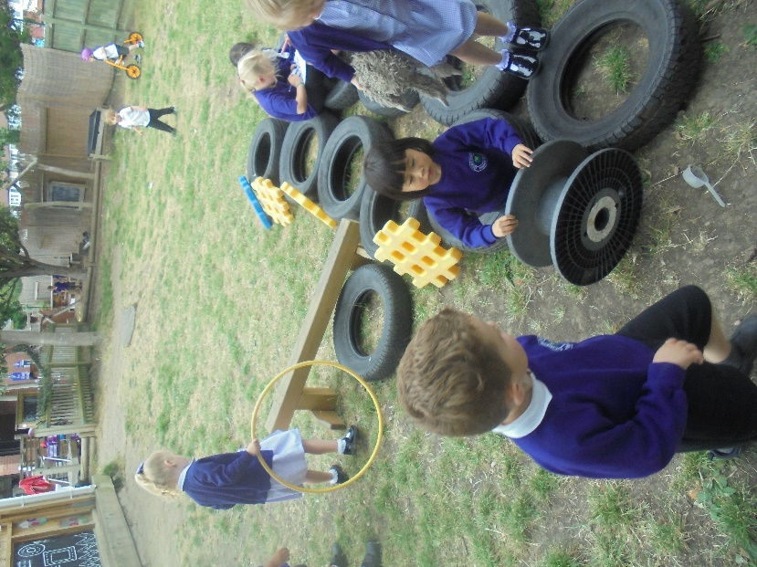

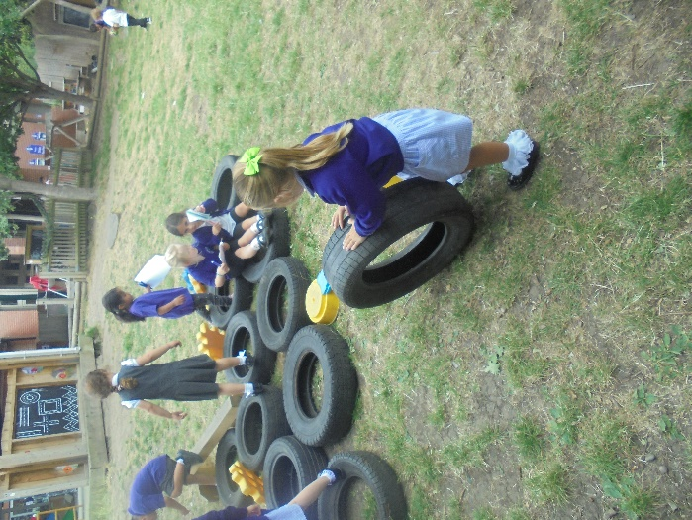
The children have shown amazing teamwork skills as they had a go at building their very own pirate ship. Some were even walking the plank — be careful!
Important Dates
New Nursery Parent Induction Evening: Thursday 3rd July 2025, 7:00pm
This event is for the parents/carers of children who will be staying in Nursery at Dorchester Primary School. Come and find out all about our Nursery curriculum and meet other parents/carers that will form our Nursery community next year.

Nursery end of year celebration: Thursday 17th July 1:30pm. Parents/carers will be invited to join us as we celebrate the learning of the children who will moving to Reception (whether this is at Dorchester or elsewhere). We hope to have a family picnic in the garden beforehand (weather permitting). If your child is staying in Nursery or moving to another Nursery they will not be part of the performance but they are of course welcome to come and watch. All families are welcome to join us for the picnic. Further details to follow.
Last day of term: Thursday 17th July 2025

