

Starting Nursery in September 2026

Information for Applicants

For children born between 1st September 2022 and 31st August 2023

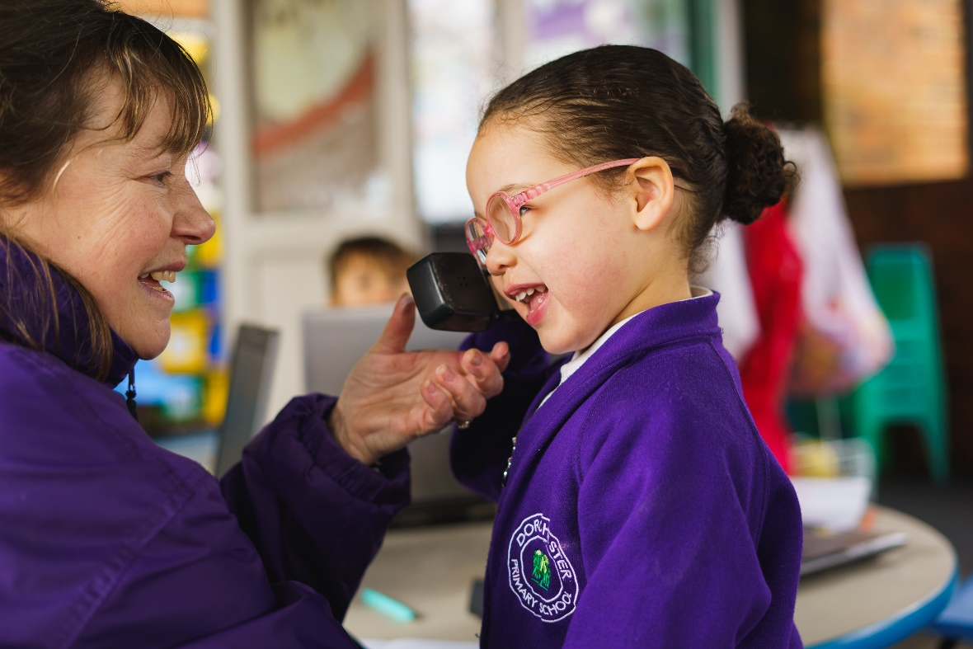

Index

Introduction 3
When can my child start nursery? 3
Can my child start nursery earlier? 3
Can my child start nursery later? 3
Are places full time or part time? 3
How do I decide which nursery I prefer? 4
What if there are more applicants than places available? 4
Do I get priority for a reception place if my child attends the nursery? 4
How do I apply for a nursery place? 4
Completing the Application Form 5
When will I know if my application is successful? 8
Can I defer my child’s place at nursery? 9
What if I miss the closing date for applications? 9
Change of address 9
Can I apply for a nursery place in another Sutton school or a school
outside Sutton? 9
I do not live in Sutton, can I apply for a nursery place at Dorchester Primary 10
What if my child has Special Educational Needs? 10
How will waiting lists be managed? 10
Information about nursery funding for three and four year olds 11
Useful Information 12

Introduction

This booklet explains how you can apply for a nursery place at Dorchester Primary School.

Our main intake for nursery is in September. The earliest that a child will normally be considered to start at Dorchester Primary School nursery is at the beginning of the September following their third birthday. It may, however, be possible for younger children to gain a place starting mid-way through the academic year if places are available. Details of this are below.

Children born between 1 September 2022 to 31 August 2023
If your child was born between these dates, you should apply for his or her nursery place before the deadline of 15 January 2026. Your child will be eligible to begin nursery in September 2026 or January 2027 if there are places available.

Can my child start nursery earlier?

No, a child must be no younger than three years of age when they start nursery school. Alternative provision for younger children may be available in private nursery provision. For more information on private nursery provision please contact the Family Information Service.

The Family Information Service
Tel: 020 8770 6000

Can my child start nursery later?

It may be possible to start nursery later in the academic year, subject to the availability of places. However, you should note that our nursery will probably fill up in September, so it is likely that there will be no places available in the nursery. If you are offered a place and do not wish to take it up immediately, you will forfeit your place and be placed on a waiting list for a vacancy later in the year.

Are places full time or part time?

Currently Dorchester Primary offer a mixture of part-time (15 hours per week) nursery places which are five mornings and five afternoons, and fulltime places (30 hours per week). The morning session runs from 8.30am to 11.30am and the afternoon session is 12.15pm-3.15pm. The fulltime sessions run from 8.30am to 2.30pm. There is an opportunity for the sessions to be extended to 3.15pm but there is a small charge for this – please ask at the school office.

How do I decide which nursery I prefer?

We recommend that you visit the school to view the Nursery. We hold Open Events during the Autumn term for parents/carers. Please visit the school website to reserve your place.

What if there are more applicants than places available?

When the school is oversubscribed, places will be allocated according to the following oversubscription criteria:

- Looked After Children and previously Looked After Children (see page 6 for more details).

- Children who have a professionally supported medical or exceptional social reason for attending a particular nursery (see page 6 for more details).

- Children with an older brother or sister attending the main school or Dorchester Primary School at the time that the younger child starts nursery (see page 7 for more details).

- On the basis of proximity to the school, measured in a straight line from the child’s home address to the main entrance of the school building, with those living closer to the school receiving the higher priority.

Do I get priority for a Reception place if my child attends the nursery?

Children attending our Nursery have no priority for admission to Reception. This is to ensure that parents who have decided not to send their child to nursery will not be disadvantaged when applying for a Reception place. Therefore, it is not necessary for your child to attend our Nursery class in order to gain a place in Reception at the school. A child may attend a nursery class in one school but apply for a Reception place at a different school. You will need to make a separate application for a place in reception at the appropriate time, regardless of which nursery school (if any) your child attends.

How do I apply for a nursery place?

The application form to apply for Dorchester Primary School Nursery during the 2026/2027 academic year is available on the website: dorchesterprimary.com

The closing date for applications is 15 January 2026.
Before completing the form it is very important that you read through this booklet and that you
understand how your application will be considered.

Completing the Application Form

If you wish to apply for a nursery place at Dorchester Primary School Nursery you must complete the application form and return it by the date indicated on the form to the school office by hand or via email to office@dorchesterprimary.com.

It is important that the application form is fully and accurately completed and submitted with the appropriate documentation (see below). If there are errors or inaccuracies on the form it may delay your application.

Child’s Address
The address on the front of the form should be the child’s permanent place of residence. It should not be a business, relative or carer’s/childminder’s address, nor is it permitted for a family to use a temporarily rented address to attempt to secure a nursery place for their child. The address will normally be the parents’ address. If the parents do not live together, it should be the address of the parent with whom the child spends the majority of the time. This will normally be the parent who receives Child Benefit in respect of the child. An application can only be made from a single address. You are required to provide your child’s birth certificate and a current Council Tax bill. If you are a council tenant, you should provide a copy of your council tenancy agreement.

If there is a formal equal share custody arrangement between the two parents, the address that will be used will be the address of the parent who is claiming Child Benefit for the child.

If you move address after completing the application form, you must write to inform us as soon as possible and provide evidence of your new address (please see page 7). The address to be used in the allocation process may vary depending on the date you moved.

Any offer of a place based on where the child lives is conditional on the child being resident at the address at the closing date for application, unless a subsequent move has been accepted for allocation purposes.
Our Nursery is popular and it is important that places are allocated fairly. The school will investigate any applications:

  - Where there are any doubts about the information provided
  - Where information has been received to suggest a fraudulent application has been made
  - Where records show a change of address within the previous 12 months

The school reserves the right to seek evidence from parents, council records, primary schools or any other sources deemed appropriate. The school may also make a home visit and refer cases to the London Borough of Sutton’s Investigation Officers where benefits are in payment.

Any application which uses false information will be withdrawn and may be subject to legal proceedings. If an application is found to be fraudulent after places are offered, the place will normally be withdrawn.

Parent/Carer’s Details
The person applying on behalf of the child should be the person with Parental Responsibility for the child. However, there may be occasions where this is not the case, and this should be indicated on the form.

Parental Responsibility is defined by the Children Act 1989 and amended by the Adoption and Children Act 2002. Parental Responsibility is automatically acquired at birth by the natural mother and natural father, if he was married to the mother at the time of birth or they were married subsequently. For children born since 1 January 2003, the child’s natural father will have Parental Responsibility if he jointly registered as the child’s natural father following the child’s birth. Other people can obtain Parental Responsibility by seeking a Parental Responsibility legal agreement, obtained with the consent of all persons with Parental Responsibility or by a court order, or when a child is placed with them for legal adoption. Step-parents, grandparents and other close relatives do not have automatic Parental Responsibility, and can only acquire it through a legal agreement or court order. If you are a distant relative or not related at all to the child it is likely that you are a Private Foster Parent. In law this means you must tell your local Council you are caring for the child and also you must tell the child’s parents (or the person with Parental Responsibility) about the application for a school place and obtain their permission. You can find more information of Parental Responsibility at www.direct.gov.uk/parents under Parents’ and children’s rights.

If you are unsure about your status, you should submit your application with a covering letter to explain your situation.

Looked After Children
Children who are Looked After by a Local Authority receive top priority for a school place. As such, if the child you are applying for is Looked After, it is important that you include this on the application form and provide supporting evidence from a social worker.

A 'looked after child' or a child who was previously looked after but immediately after being looked after became subject to an adoption, child arrangements, or special guardianship order91 including those who appear to the admission authority to have been in state care outside of England and ceased to be in state care as a result of being adopted. A looked after child is a child who is (a) in the care of a local authority, or (b) being provided with accommodation by a local authority in the exercise of their social services functions (see the definition in Section 22(1) of the Children Act 1989).

Social/Medical Reasons
If you wish to apply under exceptional medical and social criteria, you must provide additional information and professional evidence to support your case which should be attached to your application form. Supporting evidence should be provided from a professional, such as a social worker, health visitor, housing officer, the police, doctor and/or hospital consultant. Refugee and Asylum Seeking children may be included under this criterion depending on individual circumstance and subject to support from a relevant professional or council officer as listed above.

Providing professional evidence does not guarantee your child priority at the school. The decision will be made by our admissions panel, who will consider whether the circumstances warrant a child being placed at our nursery and whether they should give the child priority over other applicants who may, for example, have siblings at the school or who may live closer.

If there are supported medical and social needs, consideration for a priority place will normally only be given for our nursery if it is the nearest, unless you can demonstrate why our nursery, which may be further away than another, will be more appropriate for your child’s needs.
Evidence to support a medical condition can come from the family GP or child’s hospital consultant. This should confirm your child’s condition and outline how it is managed. It should also
confirm how it would affect your child in school and its relevance to a nursery placement. Common ailments such as asthma would not normally be given a priority placement. Any other medical
conditions in the family may be considered but as a separate issue under social reasons. Parents are responsible for providing the evidence to support an application for medical or social placement. Any application that does not have supporting evidence will not be given priority.

Please note that it is not possible for routine child-minding arrangements to be taken into account as an exceptional social reason.

Siblings
A sibling is defined as brother or sister, half brother or sister, adopted brother or sister, step brother or sister, or the child of the parent/carer’s partner, and in every case, who is living as part of the same family unit at the same address, Monday to Friday. If your child will have a sibling in our main school it is important that you include the sibling’s details on the form to ensure that, if applicable, sibling priority is given. You should not name any child who is not a sibling, nor any child who will not be in attendance when the younger child is due to start.

Returning Your Application Form
Forms can be posted or hand delivered to the Admissions Officer, Dorchester Primary School, Dorchester Road, Worcester Park, Surrey, KT4 8PG. It can also be sent via email to office@dorchesterprimary.com

Please note that if you wish to hand your form in to someone in person, you must bring
your form to the school office between 9.00 a.m. and 4.00 p.m.

Supporting Evidence
You MUST include:
- Evidence of address – current council tax bill or if you are a council tenant a copy of your tenancy agreement
- Evidence for social/medical reasons to be considered
- Copy of your child’s birth certificate

Closing Date
The closing dates for application are shown on page 4 and on the application form.

Applications made after the closing date will be considered after those received on time, unless there are exceptional circumstances, supported by independent evidence.

Acknowledgement of Applications
Applications will not be acknowledged unless requested, and in the case of postal applications, accompanied by a stamped addressed envelope.

When will I know if my application is successful?

Letters giving the results of applications will be communicated prior to 27th March 2026 and for children starting in January 2027, 03 December 2026.

You will be told if we are able to offer a place for your child. Where an offer is made, you will be given two weeks to decide whether or not you want to accept the place.
If you are not offered a place you will be asked if you would like your child’s name to be put on the waiting list for the remainder of the academic year. Vacancies arising after the initial allocation will be offered to children on the waiting list, based on the admission arrangements set out on page 4.

There is no formal appeal system if you do not get offered a place in our nursery; if this is the case do contact the school office and we will do our best to advise further.

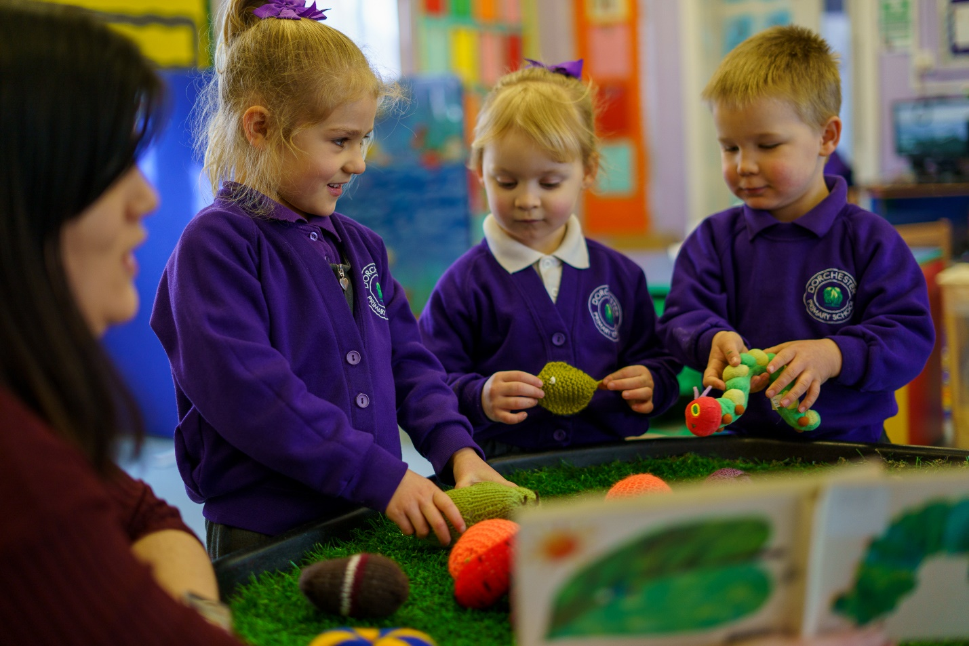

Can I defer my child’s place at nursery?

No. If you are offered a place in our nursery but you do not wish your child to start until a later term, the place will be withdrawn and your child’s name will be placed on the waiting list for the later term.

However, you should note that Dorchester Primary School Nursery is usually full in the Autumn term, and as such, there is no guarantee that a place will become available later in the year.

What if I miss the closing date for applications?

If you miss the closing date your application will be treated as a late application. If vacancies remain at Dorchester Primary School Nursery after all on-time applications have been considered you may be allocated a place. However, this is unlikely as our Nursery class is very popular.

Change of address

If you move at any time after submitting an application to us, you must advise us immediately and provide proof of your new address, so that we can update our records and ensure that correspondence is sent to the correct address. Proof of your new address should include either a copy of your tenancy agreement or a copy of a solicitor’s letter confirming the sale/purchase (this must be after completion has taken place). Exchange of contracts or a future completion date will not be accepted.

The address to be used in the allocation of nursery places may vary depending on the date you moved, and as such, failure to tell us about a new address may result in an incorrect allocation of nursery places. If you fail to tell us about a house move, we may withdraw your application or any offer of a nursery place that has been made.

Can I apply for a nursery place in another Sutton school or a school outside Sutton?

Yes, you can apply for a nursery place in a London Borough of Sutton school using their application form. You can also apply for a nursery place in another borough but you will need to do this on a different form. You will need to contact the Local Authority where the nursery is situated for details of their admission arrangements and how to apply.

I do not live in Sutton, can I apply for a nursery place at Dorchester Primary School?

Yes. If you live outside the Borough you can still apply for a nursery place. However, if we are oversubscribed places will be allocated based on the arrangements set out on page 4, one of which includes the distance of the home address from the school.

What if my child has Special Educational Needs?

If your child is not yet going to an early education setting, you can talk to your doctor or health visitor who will be able to give you advice about the next steps to take. If your child is offered a place with us and you are concerned about Special Educational Needs, we will arrange for you to meet our Special Educational Needs Co-Ordinator prior to your child starting with us.

How will waiting lists be managed?

Your child will automatically be added to our waiting list in the following circumstances:

- If you are not offered a place at the initial allocation
- If you submit a late application, and we are oversubscribed with applications who applied on time
- If you are applying for a nursery place for a child who is already 3 years of age and we are already full

The waiting list will be ranked according to the school’s admission criteria as set out on pages 4. No priority can be given to children according to the date their application was received or when their name was added to the list.

As some families decline their offer of a nursery place, vacancies are created. These will be filled from the waiting lists.

You should note that your child’s position on a waiting list may go down as well as up. This is because other children might be added to the nursery’s waiting list that have a greater priority for a place against the admission criteria. This can happen when new families move into the area or when other families ask to go on the waiting list for a nursery after the initial allocation date.

Information about nursery funding for three and four-year-old children

The Government provides funding for all four year old children and most three year old children to attend a nursery. The nursery can be in the private sector (that is, a private day nursery, pre-school or playgroup), or in the maintained sector (that is, a local authority school or academy). If the nursery is in the private sector, it must be inspected by OFSTED and registered with Sutton Extended Services and Early Years.
The funding is available for 15 hours a week, for 38 weeks of the year. The payment goes directly to the nursery provider and will cover the cost of a place in most private nurseries and all local authority or academy nurseries.

The table below shows when your child is eligible for a grant

3rd Birthday between | Grant will be from
1st January – 31st March | Summer Term  (starting after Easter) onwards
1st April – 31st August | Autumn Term  (beginning in September) onwards
1st September – 31st December | Spring Term  (beginning in January) onwards

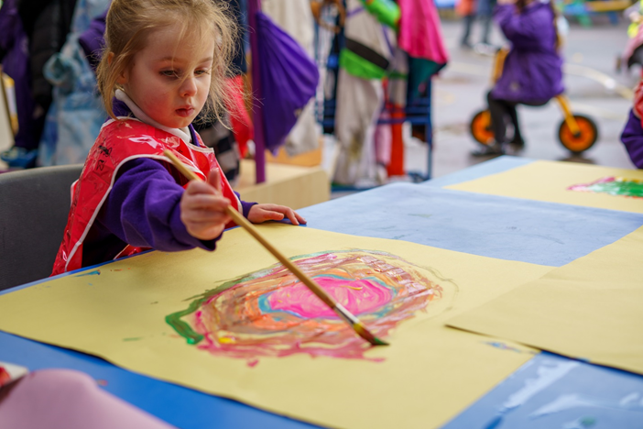

Useful Information

For further information about nursery provision in Sutton and the funding available, please contact the Family Information Service, Tel: 020 8770 6000

The Sutton online Family Information Directory to search for childcare, activities and other support services can be visited at www.sutton.gov.uk

Points to note:

- Visit some nurseries before completing your application form; this will help you to find the right environment for your child.
- You should bear in mind that the nearer you live to the nursery the more likely it is that your application will be successful. However, there is no guarantee of being offered a place.
- Medical reasons only apply to the child and must be supported by evidence which shows why a particular nursery is the only one your child can attend. Confirmation of a condition will not necessarily be sufficient to give medical priority. Please see page 6 for more information.
- Social reasons do not include routine childminding arrangements but may include medical conditions relating to another member of the family. Please see page 6 for more information.
- In all cases it is your responsibility to provide the evidence to support a request for a priority placement. The school will not seek evidence on your behalf.
- If you are not offered a place in our nursery you can apply for an alternative nursery. You can accept an alternative offer and leave your child’s name on our waiting list.
- Before returning your application please check that you have included the following information:
  - Child’s name
  - Child’s date of birth
  - Your postcode
  - Evidence of your child’s date of birth (preferably birth certificate)
  - Any relevant medical or social evidence to support your application
  - Current council tax bill or council tenancy agreement
  - Details of siblings in Dorchester Primary School
  - Please sign and date the form

- If your circumstances change after you have submitted your form, you must notify us in writing to:

School Admissions
Dorchester School
Dorchester Road Worcester Park
Surrey KT4 8PG
Email: office@dorchesterprimary.com

